DMV Assignment 6

Syed Muhammad Hassan Raza – 26645

Q1: List all orders where the customer's email domain is 'gmail.com' the order mode is direct, and customers first three digits of the phone number (AFTER +1) are 517.

SELECT * FROM OEHR_ORDERS A

INNER JOIN OEHR_CUSTOMERS B

ON A.CUSTOMER_ID=B.CUSTOMER_ID

WHERE CUST_EMAIL LIKE '%GMAIL.COM' AND ORDER_MODE = 'DIRECT' AND PHONE_NUMBER LIKE '+1 517%'

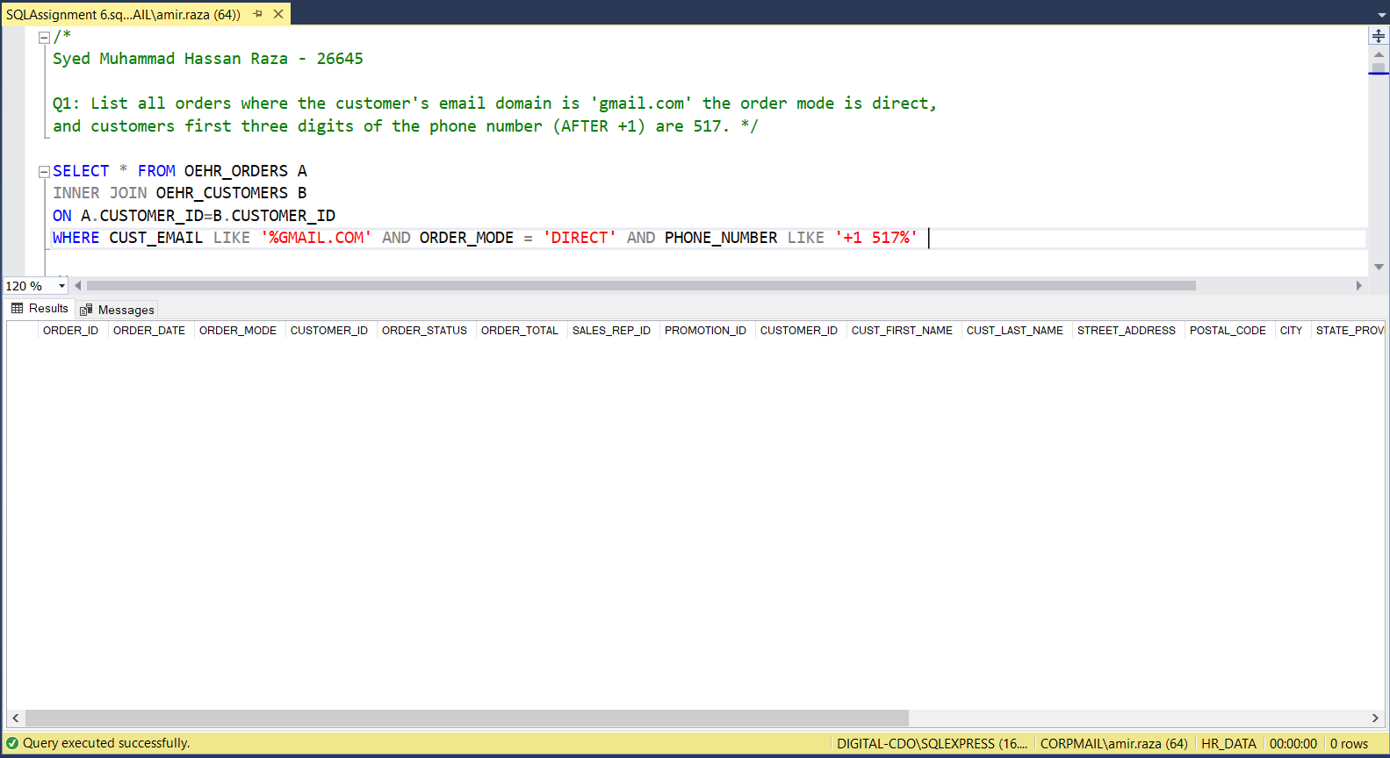

Q2: Find the names of employees whose last name has exactly 5 characters and contains the substring 'man' anywhere in the name.

SELECT FIRST_NAME, LAST_NAME

FROM OEHR_EMPLOYEES

WHERE LEN(LAST_NAME) = 5 AND (LAST_NAME LIKE '%MAN%' OR FIRST_NAME LIKE '%MAN%')

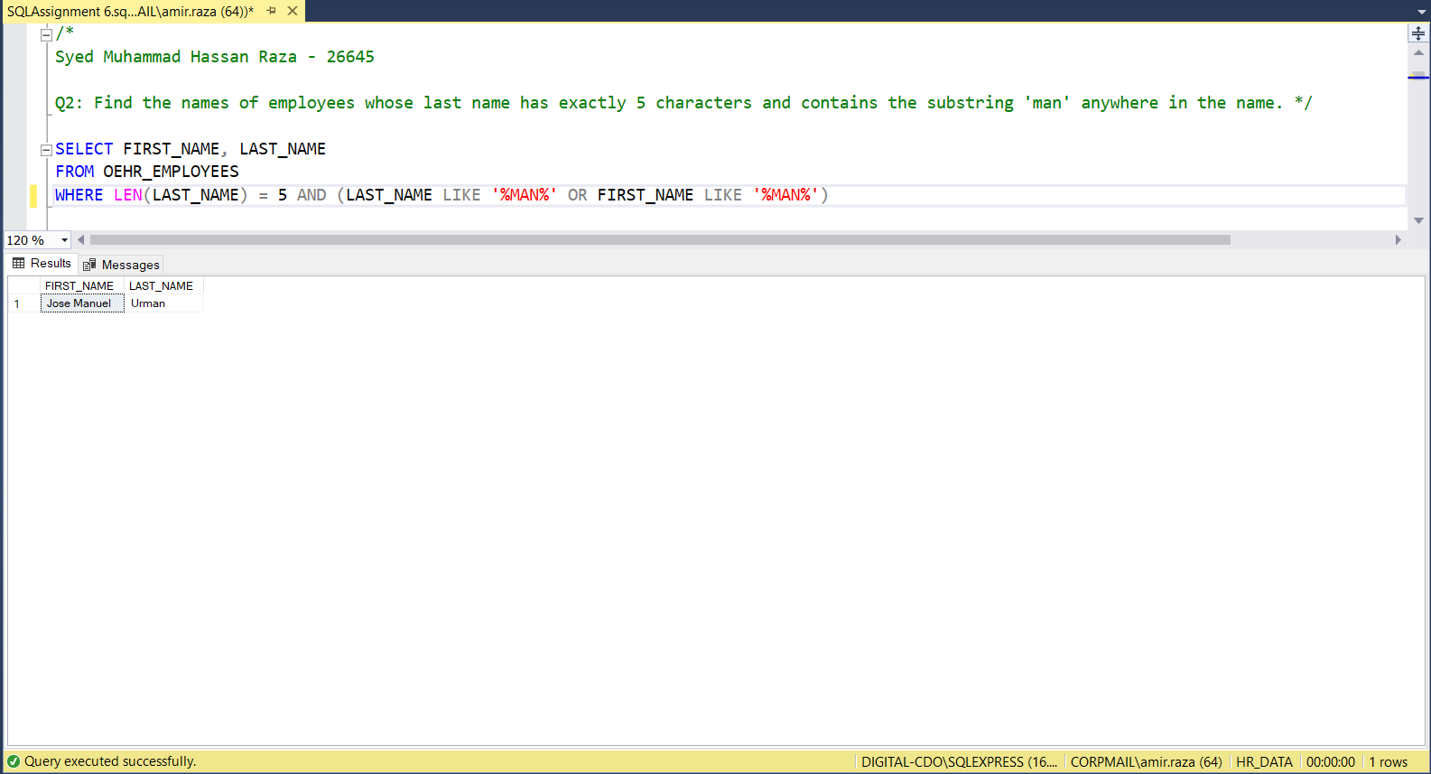

Q3: List all employees whose manager's first name contains 'an' and have a salary above the average salary of their department.

SELECT A.EMPLOYEE_ID, A.FIRST_NAME, A.LAST_NAME

FROM OEHR_EMPLOYEES A

INNER JOIN (SELECT * FROM OEHR_EMPLOYEES

WHERE EMPLOYEE_ID IN (SELECT MANAGER_ID FROM OEHR_EMPLOYEES)) AS MANAGERS

ON A.MANAGER_ID = MANAGERS.EMPLOYEE_ID

WHERE MANAGERS.FIRST_NAME LIKE '%AN%'

GROUP BY A.FIRST_NAME, A.LAST_NAME, A.EMPLOYEE_ID, A.DEPARTMENT_ID

HAVING AVG(A.SALARY) > (SELECT AVG(SALARY) FROM OEHR_EMPLOYEES WHERE DEPARTMENT_ID = A.DEPARTMENT_ID)

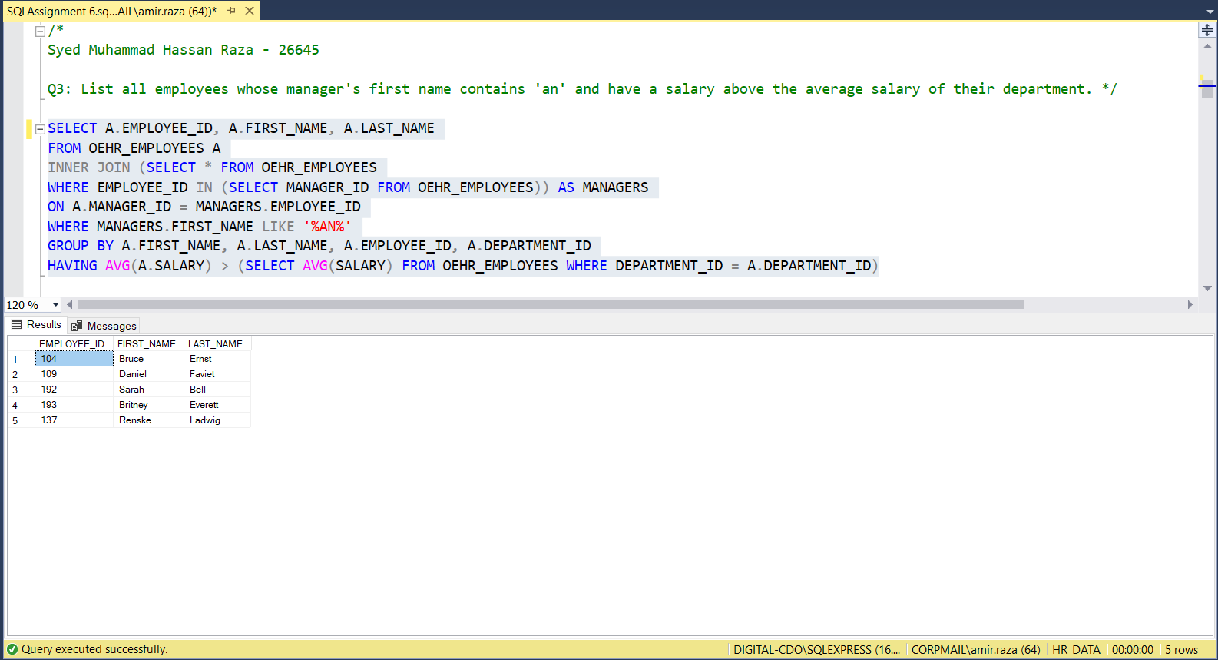

Q4: Retrieve the product IDs and names of products that have been sold more than three times and have 'for' in their translated name, considering only the first 6 characters after trimming any leading or trailing spaces.

SELECT B.PRODUCT_ID, B.PRODUCT_NAME

FROM OEHR_ORDER_ITEMS A

INNER JOIN (SELECT C.PRODUCT_ID, PRODUCT_NAME, LEFT(LTRIM(RTRIM(TRANSLATED_NAME)),6) AS TRIMMED_NAME

FROM OEHR_PRODUCT_INFORMATION C

INNER JOIN OEHR_PRODUCT_DESCRIPTIONS B

ON C.PRODUCT_ID = B.PRODUCT_ID

WHERE LEFT(LTRIM(RTRIM(TRANSLATED_NAME)),6) LIKE '%FOR%') B

ON A.PRODUCT_ID=B.PRODUCT_ID

GROUP BY B.PRODUCT_ID, B.PRODUCT_NAME

HAVING COUNT(A.PRODUCT_ID)>3

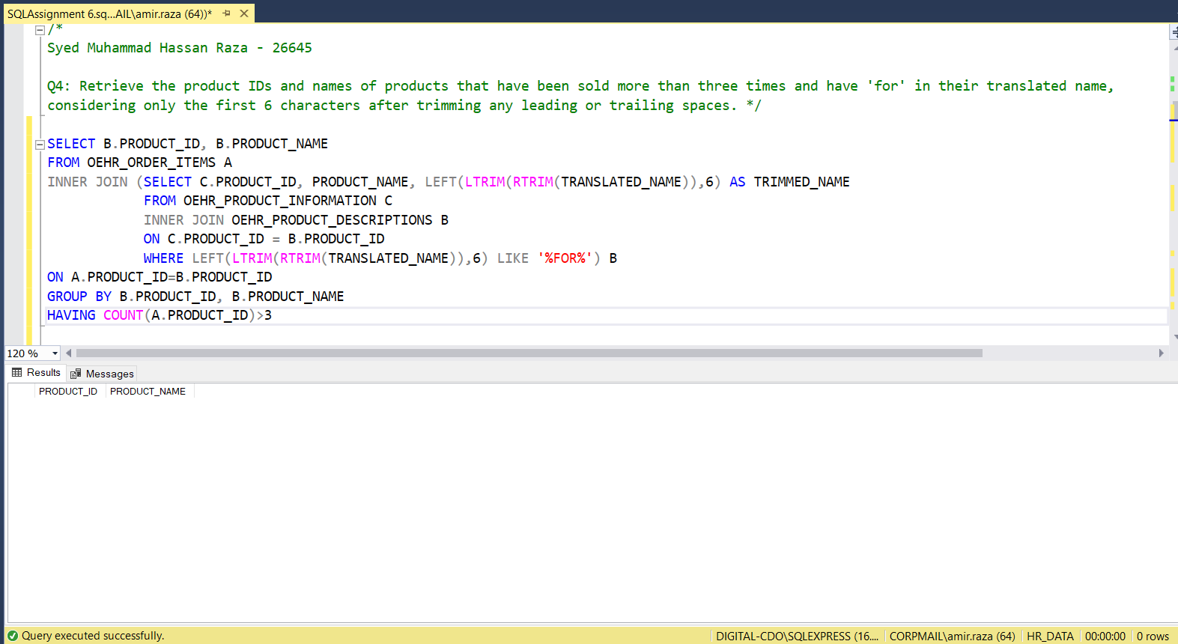

Q5: Find the customer names and their total purchase amounts for customers who have made more than 3 orders, using CTEs.

WITH CUSTOMER_ORDERS AS

(SELECT CUST_FIRST_NAME, CUST_LAST_NAME, SUM(ORDER_TOTAL) 'TOTAL PURCHASE AMOUNT', COUNT(B.CUSTOMER_ID) AS NUMBER_OF_ORDERS

FROM OEHR_CUSTOMERS A

INNER JOIN OEHR_ORDERS B

ON A.CUSTOMER_ID=B.CUSTOMER_ID

GROUP BY CUST_FIRST_NAME, CUST_LAST_NAME)

SELECT * FROM CUSTOMER_ORDERS

WHERE NUMBER_OF_ORDERS > 3

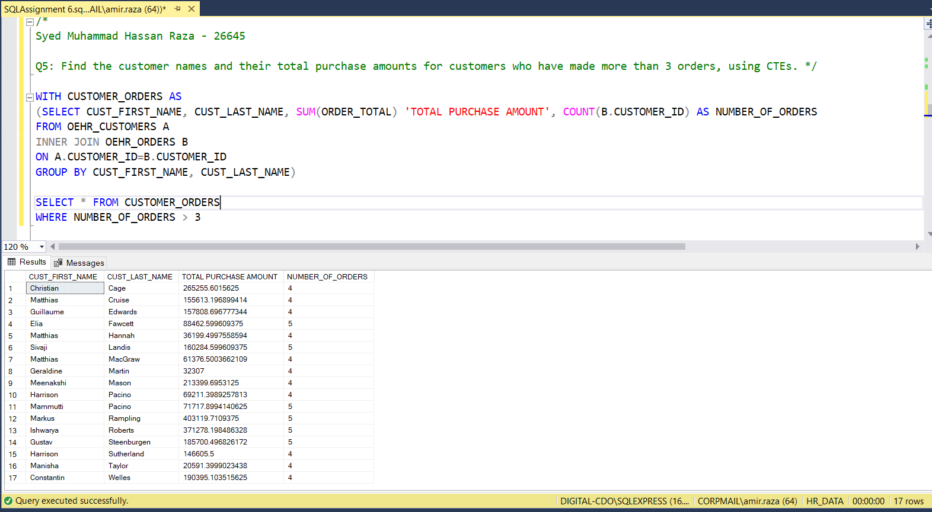

Q6: Retrieve the product IDs and names of products that have been sold more than 4 times and have 'wireless' in their name, considering only the first 8 characters after trimming any leading or trailing spaces, using CTEs.

WITH TRIMMED_DETAILS AS

(SELECT LEFT(LTRIM(RTRIM(PRODUCT_NAME)),8) AS TRIMMED_NAME, A.PRODUCT_ID, PRODUCT_NAME, COUNT(B.PRODUCT_ID) AS NUMBER_OF_ORDERS

FROM OEHR_PRODUCT_INFORMATION A

INNER JOIN OEHR_ORDER_ITEMS B

ON A.PRODUCT_ID = B.PRODUCT_ID

GROUP BY A.PRODUCT_ID, PRODUCT_NAME)

SELECT * FROM TRIMMED_DETAILS WHERE NUMBER_OF_ORDERS > 4 AND TRIMMED_NAME LIKE '%WIRELESS%'

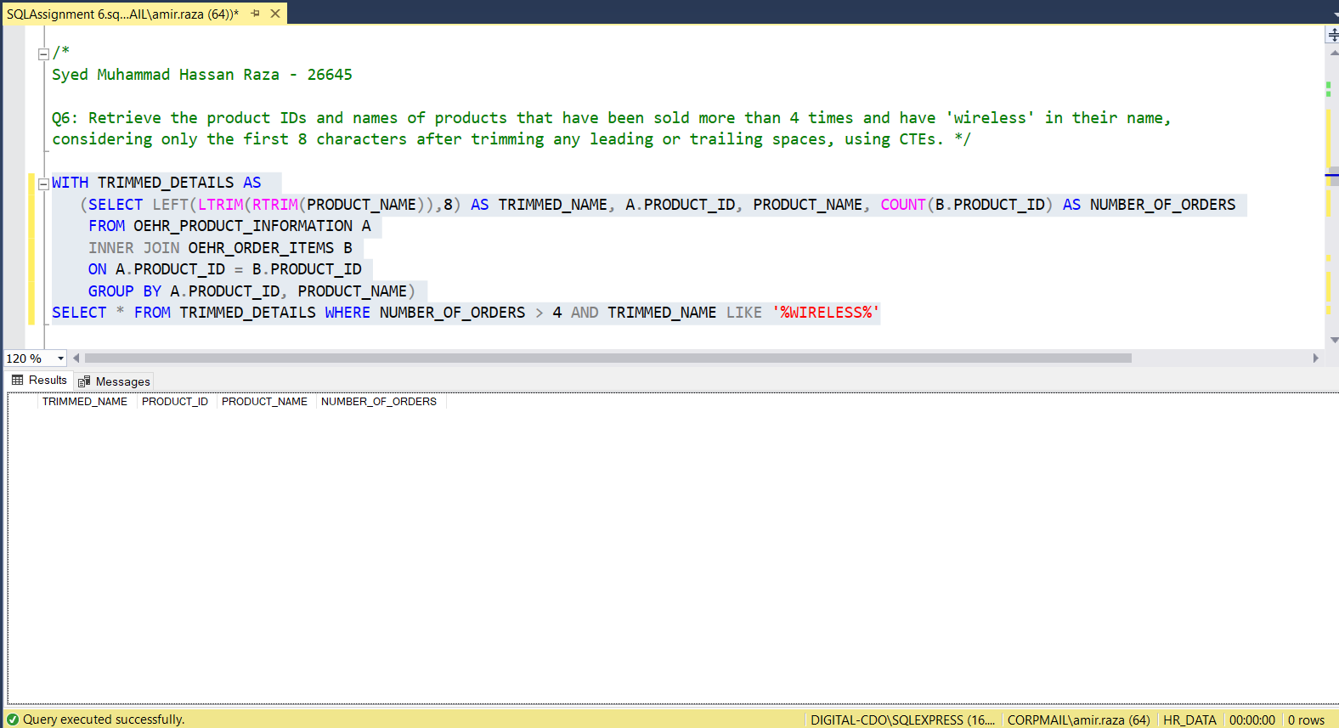

Q7: Retrieve all orders placed by customers who have spent more than the average amount.

SELECT A.* FROM OEHR_ORDERS A

INNER JOIN (SELECT CUSTOMER_ID

FROM OEHR_ORDERS C

GROUP BY CUSTOMER_ID

HAVING SUM(ORDER_TOTAL) > (SELECT AVG(ORDER_TOTAL) FROM OEHR_ORDERS WHERE CUSTOMER_ID = C.CUSTOMER_ID)) B

ON A.CUSTOMER_ID = B.CUSTOMER_ID

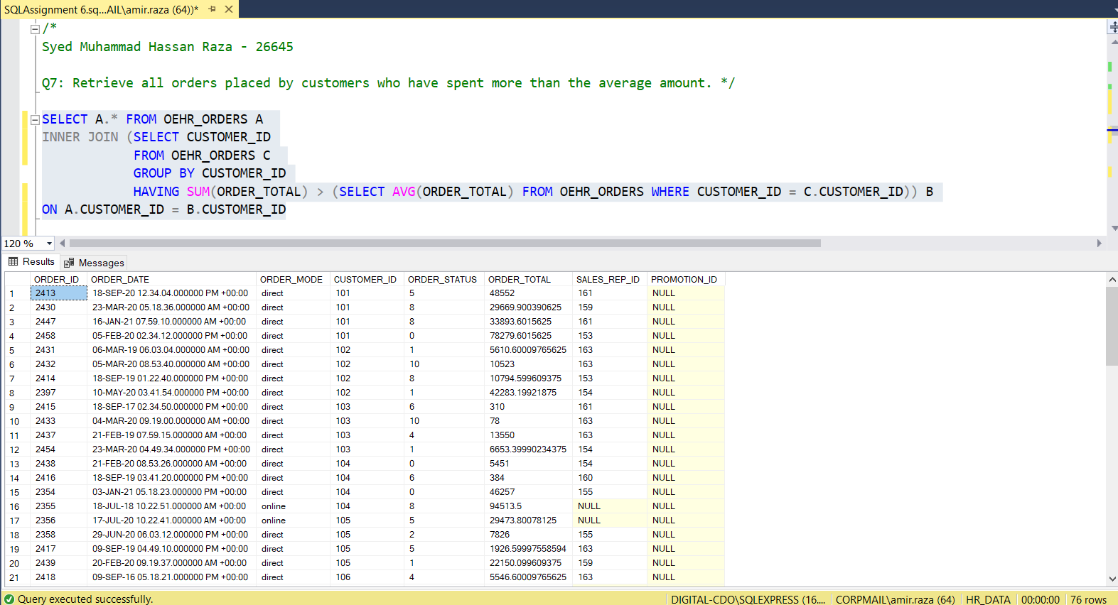

Q8: Find all customers (customer ID and customer name) along with the total spending of each customer compared to the maximum spending among all customers. (two columns for customer id and customer name, one column for total spending of each customer, one column for maximum spending among all customers, total 4 columns).

SELECT A.CUSTOMER_ID, CUST_FIRST_NAME, SUM(ORDER_TOTAL) AS TOTAL_SPENDING,

(SELECT MAX(TOTAL_SPENDING)

FROM (SELECT SUM(ORDER_TOTAL) AS TOTAL_SPENDING

FROM OEHR_ORDERS GROUP BY CUSTOMER_ID)

AS TOTAL_SPENDING) AS MAX_SPENDING

FROM OEHR_ORDERS A

INNER JOIN OEHR_CUSTOMERS B

ON A.CUSTOMER_ID = B.CUSTOMER_ID

GROUP BY A.CUSTOMER_ID, B.CUST_FIRST_NAME

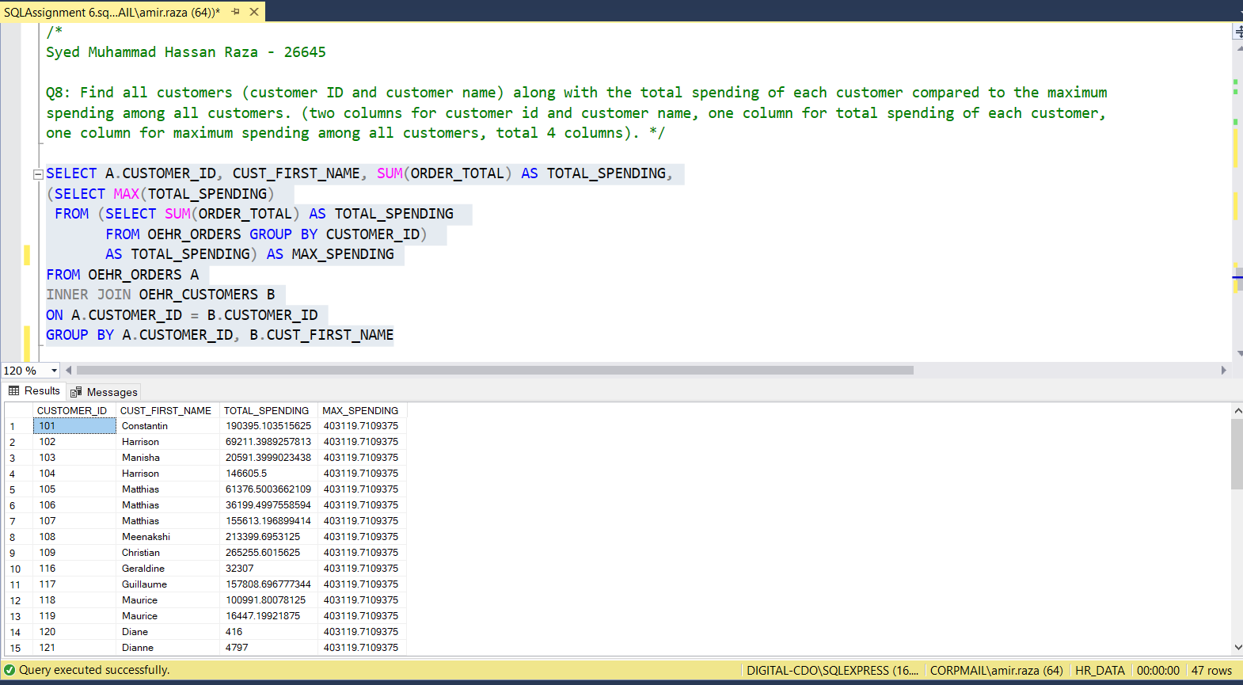

Q9: Find all employees and their corresponding salaries. If an employee's salary is below the average salary of their department, display 'Below Average' instead of the salary.

SELECT FIRST_NAME, LAST_NAME, SALARY,

CASE

WHEN SALARY < (SELECT AVG(SALARY) FROM OEHR_EMPLOYEES WHERE DEPARTMENT_ID = A.DEPARTMENT_ID)

THEN 'BELOW AVG'

ELSE CAST(SALARY AS VARCHAR(10))

END AS SALARY

FROM OEHR_EMPLOYEES A

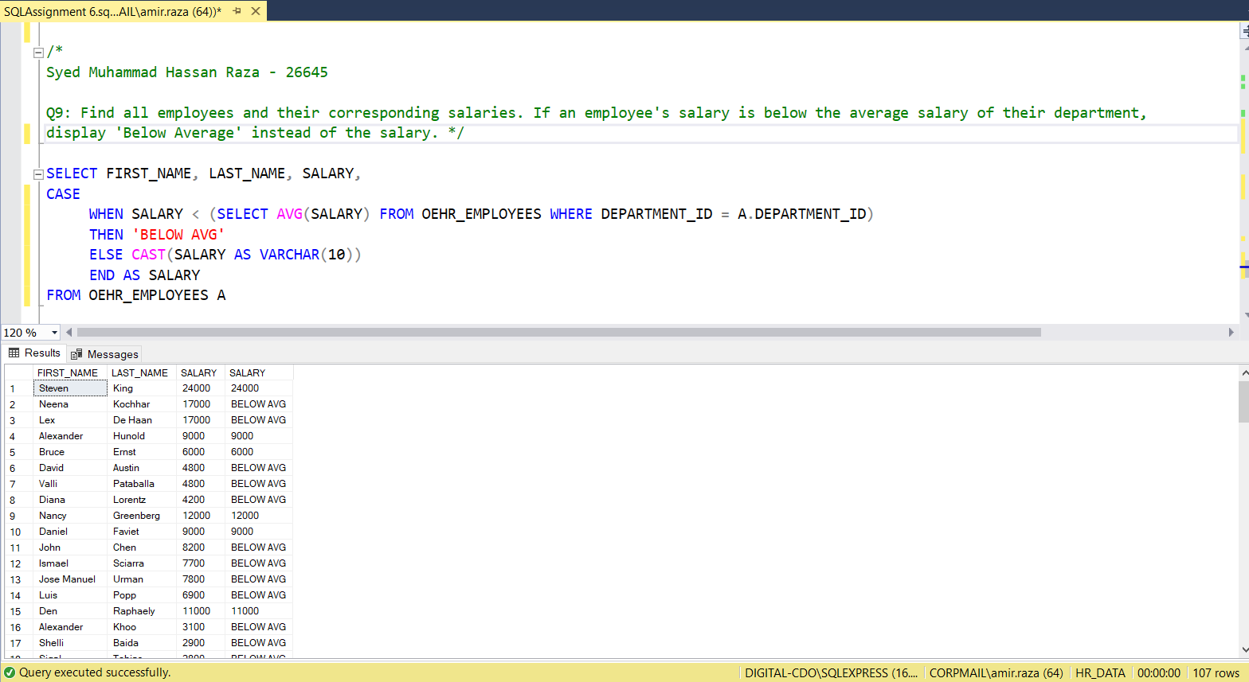

Q10: List all employees along with the number of employees they manage. If an employee does not manage any employees, display '0' instead of the count.

SELECT EMPLOYEE_ID, FIRST_NAME, LAST_NAME,

(SELECT COUNT(EMPLOYEE_ID) FROM OEHR_EMPLOYEES B WHERE A.EMPLOYEE_ID = B.MANAGER_ID) AS MANAGED_EMPLOYEES_COUNT

FROM OEHR_EMPLOYEES A

